PROJECT REPORT

ON

TOURISM MANAGEMENT

SYSTEM

Submitted By,

PRIYANKA KONA(845390)

**TABLE OF CONTENTS**

|  |  |  |
| --- | --- | --- |
| **Sl No.** | **Title** | **Page No.** |
| 1  1 | Abstract  Introduction | 3  4 |
| 2 | Software Requirement Specification | 5 |
|  | 2.1 Requirements | 5 |
|  | 2.1.1 Software Requirements | 5 |
|  | 2.1.2 Software Features | 5 |
|  | 2.1.3 Hardware Requirements | 7 |
| 3 | Architecture Design | 8 |
|  | 3.1 Data Flow Diagram | 9 |
| 4 | Snapshots | 10 |
|  | 7.1 Snapshot 1 | 10 |
|  | 7.2 Snapshot 2 | 10 |
|  | 7.3 Snapshot 3 | 11 |
|  | 7.4 Snapshot 4 | 11 |
|  | 7.5 Snapshot 5 | 12 |
|  | 7.6 Snapshot 6 | 12 |
|  | 7.7 Snapshot 7 | 13 |

|  |  |
| --- | --- |
| 7.8 Snapshot 8 | 13 |
| Conclusion and Future work References | 14  14 |

## ABSTRACT

The recent past showed a greater interest in recommender techniques. Now-a-days there are many travel packages existing from different websites to almost all the places over the world. A customer finds it very difficult to search for the best package as he/she has to browse multiple websites, contact many travel agents and etc. which is a tedious process and is time consuming. There should be a system where the user should find the best package on the Internet with a single click.

To address this issue, we adopt Tourism Management System which offers the best package among all the other packages that are on the web. This project will help tourist to suggest the best Travel Package among all the package deals on the web. On multiple demands of tourist that is, a customer will select a travel package for a particular place based on the price, date availability. Therefore, according to the personalized recommendations, he/she will choose the best package that is on the web.

# Chapter 1

## INTRODUCTION

Tourism can be considered as most favorite pass time when people get free time. Several travel organizations are available on the web. The people or the tourist select their own Travel Package according to their personal interest. The travel companies concentrate on the interest associated with tourist making sure to increase their particular market value and supply enormous package deals. So that they can make their Travel Package more effective. Now-a- days Recommender system is becoming very famous and people are getting attracted to it, as it is helping them to choose the best package in a short time.

# Chapter 2

## SOFTWARE REQUIREMENT SPECIFICATION

A software requirements specification (SRS) is a description of a software system to be developed. It lays out functional and non-functional requirements, and may include a set of use cases that describe user interactions that the software must provide.

Characteristics of good SRS:

* Complete.
* Consistent.
* Feasible.
* Modifiable.
* Unambiguous.
* Testable.

## Requirements

### Software Requirements:

User Interface : JSP, CSS

Programming Language : Java

Version : JDK 1.8

Tools : Eclipse Photon, MYSQL Workbench

Database : MYSQL

Server : Tomcat 7.0

### Software Features:

#### JAVA

Java is a high-level programming language which was developed by Sun Microsystems.It is an object-oriented language similar to C++, which was simplified to get rid of some common programming errors. Source code (files with a .java extension) of Java is compiled into a format

called bytecode (files with a .class extension), which can be executed by a Java interpreter. Operating Systems such as UNIX, the Macintosh OS, and Windows contain JVM.

#### CSS

Cascading Style Sheets (CSS) is a style sheet language used for describing the presentation of a document written in a markup language. Although most often used to set the visual style of web pages and user interfaces written in HTML,JSP and XHTML, the language can be applied to any XML document, including plain XML, SVG and XUL, and is applicable to rendering in speech, or on other media. Along with JSP and JavaScript, CSS is a cornerstone technology used by most websites to create visually engaging webpages, user interfaces for web applications, and user interfaces for many mobile applications.

#### Eclipse

Eclipse is an integrated development environment (IDE) for developing Java applications and also other languages like PHP, C/C++, and HTML5. It is also an application platform framework for Java desktop applications and others. The MyEclipse IDE is written in Java and can run on Windows, OS X, Linux, Solaris and other platforms supporting a compatible JVM.

#### MySQL

MySQL, the most popular Open Source SQL database management system, is developed, distributed, and supported by Oracle Corporation. A database is a structured collection of data. To add, access, and process data stored in a computer database, you 24 need a database management system such as MySQL Server. Since computers are very good at handling large amounts of data, database management systems play a central role in computing, as standalone utilities, or as parts of other applications.

#### Tomcat Server

Apache Tomcat is an open-source web server and servlet container developed by the Apache Software Foundation (ASF). Tomcat implements several Java EE specifications including Java Servlet, JavaServer Pages (JSP), Java EL, and WebSocket, and provides a "pure Java" HTTP web server environment for Java code to run in.

### Hardware Requirements:

* + Processor : INTEL core i3
  + MEMORY : 8 GB
  + RAM : 4 GB
  + HDD : free space of 50 G

# Chapter 3

## ARCHITECTURE DESIGN

Design of the new system begins by elaborating the statement of requirements in terms of more detailed objectives. The main aim of design process is to produce a model or representation of the system, which can be used later to bind the system. The produced model is called design/architecture of the system. A system design is a top down approach to minimize complexity and make a problem manageable by subdividing it into smaller segments.

The most changing phase of the system development of life cycle is system design. It refers to the technical specification that will be applied in implementing the candidate system. The potential objects are thoroughly analyzed. Class hierarchies are to check whether the system is behaving the way it has to. There after the classes are individually tested and subsequently they are integrated from the overall system.

### Project Flow:

1. The client sends an HTTP request to a specific URL, Dispatcher-Servlet of Spring MVC receives the request It passes the request to a specific controller depending on the URL requested using @Controller and @RequestMapping annotations.
2. Spring MVC Controller then returns a logical view name and model to Dispatcher-Servlet.
3. Dispatcher-Servlet consults view resolvers until actual View is determined to render the output.
4. Dispatcher-Servlet contacts the chosen view (like Thymeleaf, Freemarker, JSP) with model data and it renders the output depending on the model data The rendered output is returned to the client as a response.

## 3.1 Project Flow Diagram

It shows the functional component in the software package.

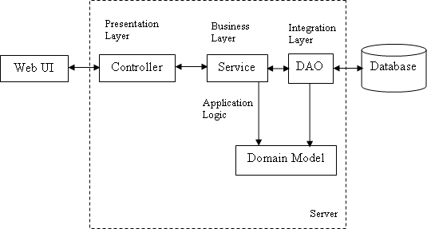

#### Fig 3.1 Project Flow Diagram

**Chapter 4**

**SNAPSHOTS**

In this chapter we will present some of the snapshots of this project.

## Snapshot 1

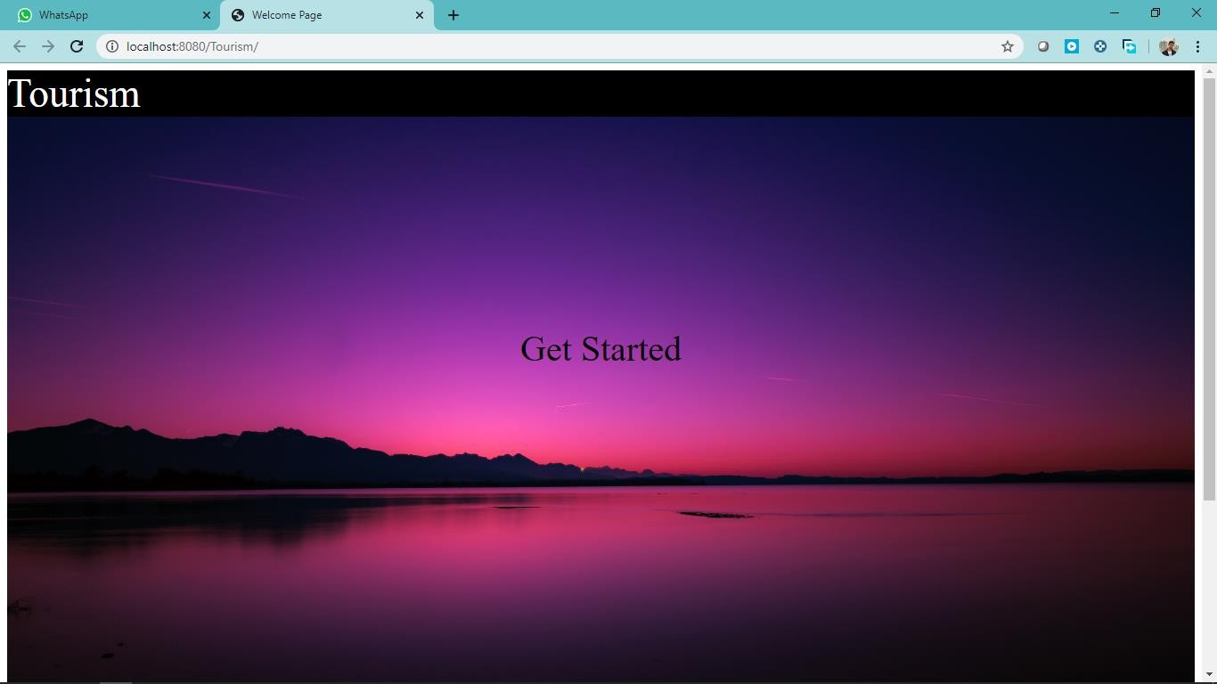

**Fig 7.1** Home Page

## Snapshot 2

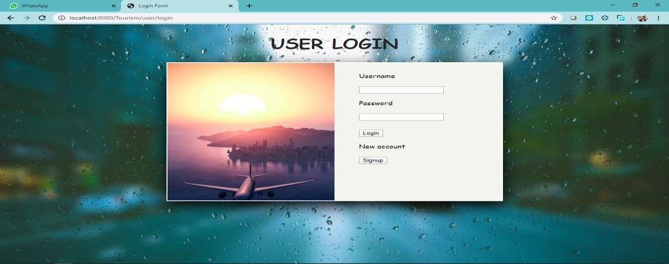

**Fig 7.2** Login Page

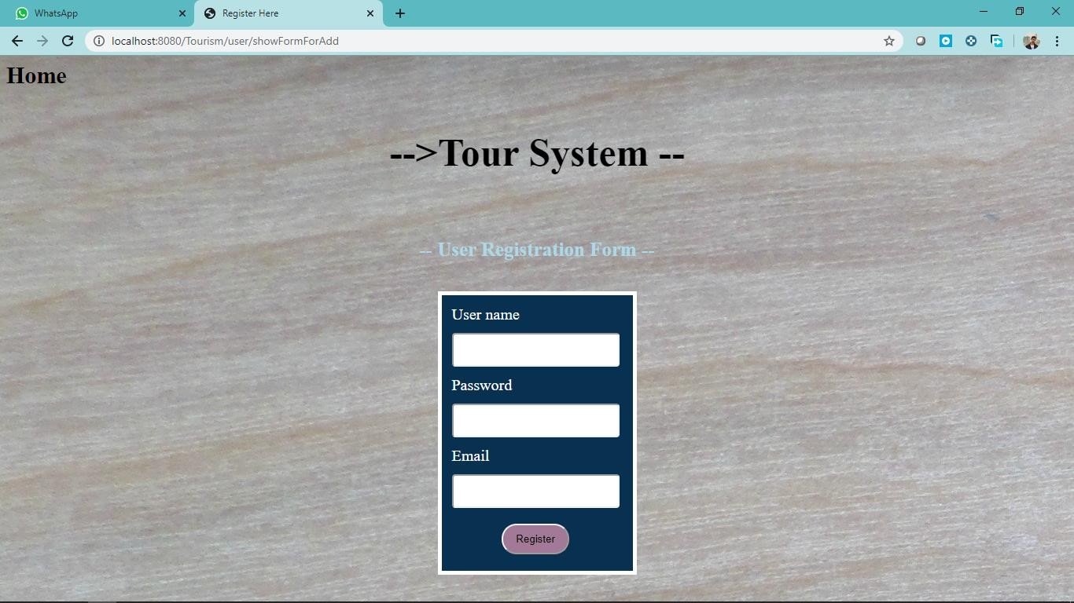

**Fig 7.3** User Registration form

## Snapshot 4

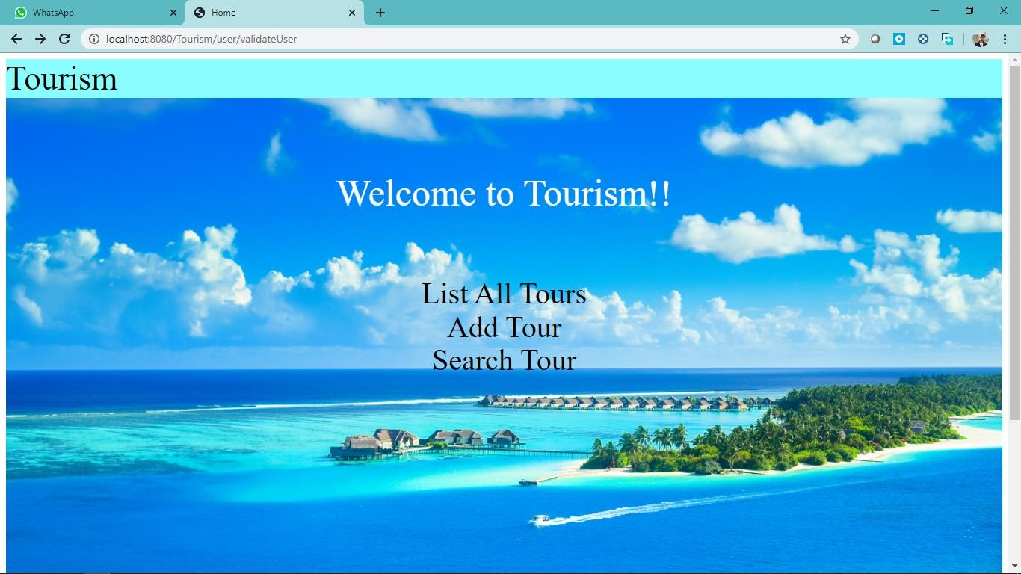

**Fig 7.4** Main Page

## Snapshot 5

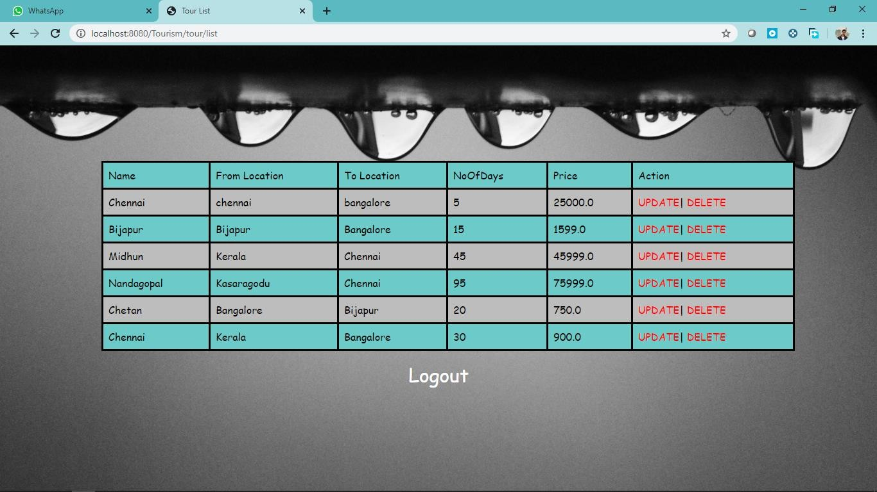

**Fig 7.5** List Of Tour Packages

## Snapshot 6

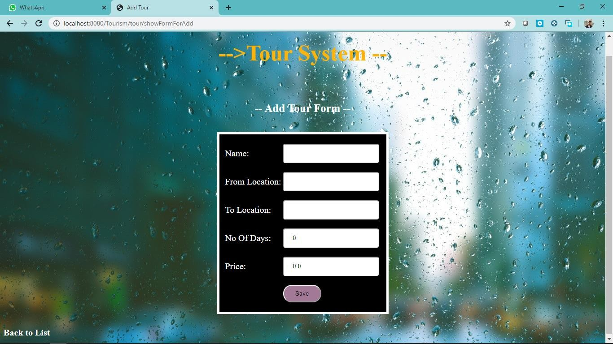

**Fig 7.6** Add New Tour Package

## Snapshot 7

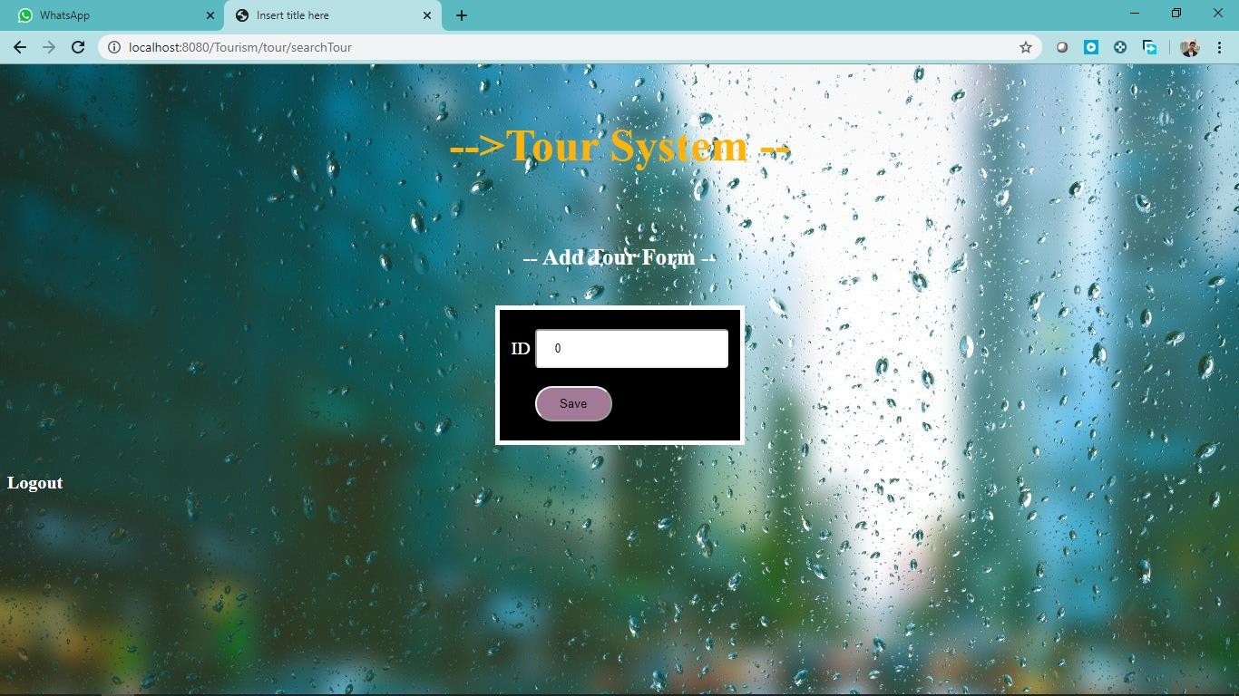

**Fig 7.7** Search A Tour

## Snapshot 8

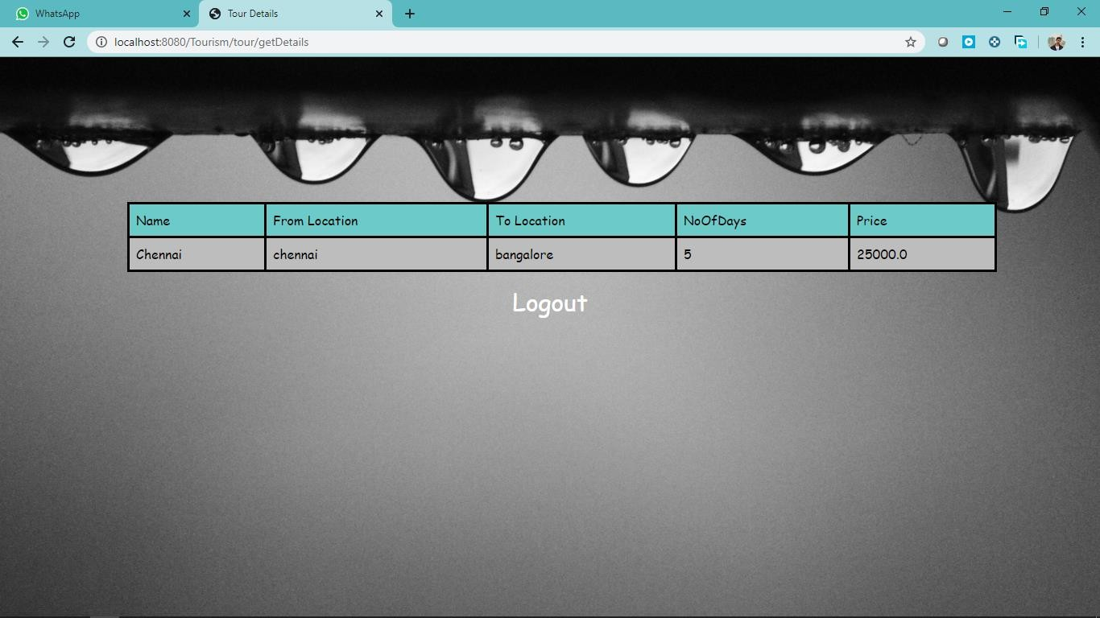

**Fig 7.8** Tour Details

## CONCLUSION AND FUTURE

This project will help to suggest the Travel package deals on the web. In this, a customer will select a travel package for a particular place will select a travel package for a particular place based on the price, availability of date. This makes easy for the user to choose the best package deal. The user can select the best package in short amount of time (instead of navigating to other websites). Finally, the goal of the project is to make an efficient system which is effective in terms of cost and money.

## References

1. https://docs.spring.io/spring/docs/current/spring-framework-reference/
2. https://docs.spring.io/spring/docs/current/spring-framework- reference/core.html#spring-core
3. https://docs.spring.io/spring/docs/current/spring-framework-reference/web.html
4. https://hibernate.org/orm/documentation/5.0/
5. https://maven.apache.org/guides/getting-started/index.html